Fall Detector for the Elderly

Using GPS and Accelerometer and Body Sensors

By Seán Hayes

Bachelor of Science (Hons) in Computing

Institute of Technology Tralee

2017

Primary Supervisor:

Secondary Supervisor:

# Abstract

Contents

Abstract 2

Chapter 1: Introduction 4

Chapter 2: Research 5

What is GPS? 5

How does GPS Work? 5

Types of Data Transmitted 5

Assisted GPS 5

Course Orbital Parameters 6

Kepler’s Laws 6

Kepler’s first law states: 6

Kepler’s Second Law 7

GPS and Satellites 8

References 8

# Chapter 1: Introduction

# Chapter 2: Research

## What is GPS?

GPS or Global Positioning System can be described as a constellation or a network of orbiting satellites that transmit accurate data of their position in space back to earth. These signals are gained by GPS revivers such as navigation devices. (Mio Technology, 2011).

## How does GPS Work?

GPS is generated by a satellite ID called the Pseudo Random Code, every satellite has a unique code, which is simply on and off pulses GPS is sent by two frequencies, these are; L1 at 157.42MHz and L2 at 1227.60 MHz. There is also two-pseudo random code, the first is called ‘Coarse Acquisition’ code that modulates L1 carrier, repeats every 1023 bits at 1MHz. The second is called ‘Precise’ code it repeats on a seven-day cycle and modulates both L1 and L2 carriers at 10MHz. (Trimble Inc.)

GPS receivers compute the position and time by using a number of satellites and ground stations. There are 24 satellites at a range of 12000 miles above earth. The information is transmitted back to earth over radio frequencies, ranging from 1.1GHz to 1.5GHz. WAAS (Wide Area Augmentation System) and DGPS (Differential Global Positioning System) are used to improve signal accuracy. WAAS is air navigation aid developed by Federal Aviation Administration and common on most GPS receivers improves accuracy to about 5 meters. DGPS on the other hand requires a specific type of GPS receiver. It gets accuracy up to centimeters. There expensive and require additional antennas. (A1RONZO, 2012)

## Types of Data Transmitted

Satellites send out two types of data Almanac and Ephemeris. Almanac data is course orbital parameters; there are six parameters to specify the motion and position fully, however very precise but valid for several months.

Ephemeris data by comparison is very precise orbital and clock correction for each SV and is necessary for precise positioning but valid for 30 minutes. The almanac enables the receiver to know which satellites to search for. A 2D position cannot be given until at least three satellites received the data from the ephemeris. This data is broadcasted every 30 seconds. (Mehaffey, 1998)

## Assisted GPS

Assisted GPS uses wireless networks to improve GPS signal. In mobiles, the computing power and good satellite signal of the ground base to the broken or fragmented information is utilized. This is achieved by receivers mounted on cellular towers. GPS can acquire a lock on the satellite more quickly and accurately. This method can be used in other devices such as cameras. (A1RONZO, 2012).

## Course Orbital Parameters

GPS satellites works by incorporating the 6 course orbit elements. These elements help GPs to output precise location and predict possible future positions. The following factors are as follows:

1) a = Semi-major axis or size  
2) e = Eccentricity or shape  
3) i = inclination or tilt  
4) ω = argument of perigee or twist  
5) Ω = longitude of the ascending node or pin  
6) v = mean anomaly or angle now

(Project Calliope, 2011)

This is all based on Kepler’s Laws.

# Kepler’s Laws

GPS are based on Kepler’s Laws. Johannes Kepler was a German Scientist who lived from 1571 to 1630. Three of his proven laws were used to construct GPS satellite systems.

## Kepler’s first law states:

‘The planets orbit on a plane. The orbit forms an ellipse with the sun at one of the foci. These laws apply to satellites, satellites orbit along a plane. Their orbit around the Earth forms an ellipse with the Earth at one of the foci.’ (Zogg, 2009, p. 35) (Figure 1).

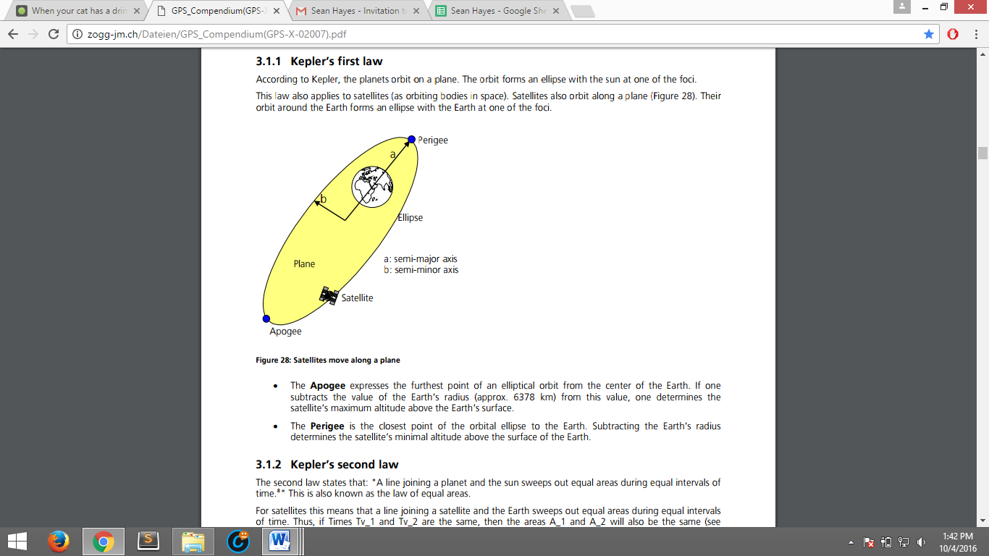

**Figure 1.**

The Apogee expresses the furthest point of an elliptical orbit from the center of the Earth. The satellite’s maximum altitude above the Earth’s surface is calculated by means of subtracting the value from the Earth’s radius.

The closest point of orbit ellipse to the Earth is called Perigee. This calculates the satellite’s minimal altitude above the surface of the Earth. (Zogg, 2009, p. 35)

## Kepler’s Second Law

The second law states that: ‘A line joining a planet and the sun sweeps out equal areas during equal intervals of time. This is also known as the law of equal areas.’ (Bryant). This corresponds to satellites by means of a line joining a satellite and the Earth that arches out equal areas during equal intervals of time. (Zogg, 2009, p. 36)

## Kepler’s Third Law

‘Kepler’s third law this law state: ‘That the squares of the orbital periods of planets are directly proportional to the cubes of the semi-major axis of the orbits’. (Zogg, 2009, p. 36). Tis means larger objects have longer orbits and the speed of a planet is slower that a smaller orbit.

$\frac{P^{2}}{a^{3}}$ is constant for all planets.

P = orbital Period, a = semi-major axis of the orbital ellipse

From this law the satellite orbital altitude (h) above the Earth’s surface can be derived:

h= $\sqrt[3]{3,9860042×{10}^{14}\frac{m^{3}}{s^{2}}×{\left(\frac{P}{2π}\right)}^{2}}-R_{e \left[m\right]}$

$R_{e}$: Radius of the Earth (6378.137km)

P: orbital period of the satellite around the Earth

(Zogg, 2009)

## GPS and Satellites

## Space Race

Satellites have played a major part in GPS technology, but how has it come to be? To answer this question we first have to start at the beginning. As the USA and USSR were battling to better one another during the Cold War, both countries would soon try and beat each other in the Space Race. The Soviets launched Sputnik I on 4th October 1957. Sputnik I would become the very first artificial satellite into space. The satellites weighing 83.6 kg, 58 cm in diameter, orbited the earth every 98 minutes. As a result, this started the “Space Race” and accelerated science, technology and military developments especially in America. America was “caught off guard”. The American public now feared the Soviets ability that they could develop missiles that could hit main land America from Europe. These fears grew further when the Soviets launched Sputnik II, with an animal passenger, a dog named Laika on November 3rd 1957. It didn’t take long for America to respond with the launch of Explorer I on January 31st 1958. By July 1958 America set up NASA or National Aeronautics and Space Administration. From here onward s America would turn the tide In the Space Race. (Garber, 2007)

## First NASA Communications Satellite - Echo 1

Echo 1 became the very first Communication Satellite launched into space on August 12 1960. The satellite or balloon was 30.48m in diameter and was constructed out of mylar polyester film 0.5 mil thick. The balloon was designed for sending telephone (voice), radio, and television signals for both transcontinental and intercontinental means. The balloon was constructed as a passive communication reflector; this means a satellite reflects communications signals between stations without a providing amplification. It transmitted on 107.9MHz beacon for telemetry measurements purpose. The reasons for the large area-to-ratio of the balloon were to allow for calculation of atmospheric density and solar pressure. For the transmitters to work the balloon was fitted with five nickel-cadmium batteries, that were charged by 70 solar cells. (Mackey, 2004)

# References

A1RONZO. (2012, December 14). *GPS Basics*. Retrieved September 27, 2016, from Spark Fun[Online]: https://learn.sparkfun.com/tutorials/gps-basics?_ga=1.267002122.566327705.1474925827

Bryant, J. (n.d.). *Keplers Second Law.* Retrieved October 4, 2016, from Demonstrations Wolfram[Online]: http://demonstrations.wolfram.com/KeplersSecondLaw/

Garber, S. (2007, October 10). *Sputnik and The Dawn of the Space Age.* Retrieved October 3, 2016, from NASA[Online]: http://www.hq.nasa.gov/office/pao/History/sputnik/

Mackey, R. J. (2004, April 2). *Echo 1.* Retrieved October 4, 2016, from NASA[Online]: http://www.nasa.gov/missions/science/f-satellites.html

Mehaffey, J. (1998, July 4). *Almanac and Ephemeris Data as used by GPS Receivers.* Retrieved September 27, 2016, from GPS Information[Online]: http://gpsinformation.net/main/almanac.txt

Mio Technology. (2011). *What is GPS?* . Retrieved October 10, 2016, from Mio[Online]: http://www.mio.com/technology-what-is-gps.htm

Project Calliope. (2011, May 31). *The 6 Classic Orbital Elements.* Retrieved September 27, 2016, from Science 2.0[Online]: http://www.science20.com/satellite_diaries/6_classic_orbital_elements-79561

Trimble Inc. (n.d.). *Pseudo Random Code*. Retrieved September 27, 2016, from Trimble[Online]: http://www.trimble.com/gps_tutorial/sub_pseudo.aspx

Zogg, J.-M. (2009). *Foundations of Satellite Technology.* Retrieved October 4, 2016, from http://zogg-jm.ch/Dateien/GPS_Compendium(GPS-X-02007).pdf